Service learning

Name
Department, Institution
Course
Professor
Date

Introduction
Mother Teresa the famous and devoted catholic nun once said “Let us not be satisfied with just giving money. Money is not enough. Money can be got, but others need your heart to love them. So, spread love everywhere you go.” This quote greatly shows the dire need for humans to extend servitude to fellow humans without necessarily wanting something in return. The same quote can be aligned to the words of Mahatma Gandhi who was a social activist, politician, and Indian lawyer who said “you must be the change you wish to see in the world.” Service-learning also involves self-devotion to society, touching people's lives by applying and reflecting on the teachings we learn in school and even the teachings from the bible. Service-learning is a bridge between practicality and theoretical implications from the books.
Organization Description
As part of service learning, I was privileged to join Mentorme which is a nonprofit making organization in the Mississippi branch. The organization is guided by a motto that goes “Every kid needs a mentor. Everybody needs a mentor.” The topmost objective of this Mentorme is to offer mentorship to youths within the age gap of 5-13 years. This mentorship program aims at ensuring that they help these children shape their vision in the journey of becoming what they intend to be in the future. In doing this the organization ensures that the pupils are given exposure in real world view on what many careers entail and showing them they have got what it takes to be what they want to be in the future. Pupils with poor academic grades are also encouraged by showing them that they are not a replica of failure. Apart from mentorship on academic-related issues the mentors also first create a bond with these youths and those with psychological issues are offered counseling as a way of helping them have a nourished life. In the daily routine of the organization, the children are introduced to bible study sessions as a way of ensuring that their spiritual life is also taken care of. As the bible says in Proverbs 16:27-29 that idle mind is the devils' workshop, the organization's aim is always to ensure that these youths are engaged in constructive activities. This is done to ensure that these youths are kept in school and off the streets. As a way of keeping them busy, the organization plans activities that are supposed to keep these children busy and these activities are activities that make the minds of these children grow.
The work I did as a service learner in Mentorme
As prior mentioned the organization is mainly engaged in mentorship programs; as a service learner, I had an opportunity of mentoring male and female youths within the age bracket of 5-13. This mentorship was mainly on helping these youths visualize the seed of greatness that they carry with them by letting them know that no human is limited and with determination and the fear of God one can go far in life. The notion that spiritual nourishment is crucial in everyone's life was not left behind during the mentorship; I articulated the dire need for the youth to remain obedient and humble to their parents and guardians as a way of getting closer to God. In that case, we read a bible verse that says happy are the meek for they shall inherit the earth. These teachings were aimed at sensitizing the youths to be humble all the time bearing in mind that the youths within that age bracket undergo so many development changes in their life’s and at times during that development, there is also a change in their behavior. As part of the organization to keep the youths busy; the organization has co-curricular that the youths get engaged in; in that connection, I involved some of them in knitting exercises as well as fishing activities. During these work interactions, I got an opportunity to bond with many of them as a mentor and after bonding, I was able to tutor them with some summer work and during the time they were able to open up to me and we discussed a lot of issues that affect them in their lives. This time most of them spoke out their hearts and mind and I was there for them and gave them appropriate answers to some of the questions they raised in the session.
The organization departments I observed as a service learner
Mentorme is an organization that takes care of children from all parts of Mississippi. This implies that they take children who are disadvantaged both from the rural area and urban area. The organization is not only limited to Mississippi but they also take children from all parts of the world who needs attention. To understand the organization better a deeper look at two organization behavior and do a mapping on the Mentorme organization which is the organization that I offered to volunteer in as part of the service-learning program.
The organization behavior concepts analyzed
Motivational theories (topic description)
Motivation can be defined as a state-of-mind, characterized by enthusiasm and energy which propels a person to work in a particular way to achieve his desired goals. Motivation is a translation of a certain kind of human behavior that normally pushes that person towards a high level of commitment and making him focus on things that might against him.
It is the responsibility of every organization to ensure that every team member is motivated to achieve the organization's goals. Some psychologists who studied human behaviors came up with theories to explain these scenarios better. In this case, two theories on motivation will be discussed and after discussion, a mapping on their manifestation in Mentorme organization will be made.

The theoretical foundation of this topic
Under this, the topics of concern to be discussed will be two motivational theories and the social system theory
Maslow’s hierarchy of needs
Abraham Maslow is the man behind Maslow's hierarchy of needs. He devised this theory in 1954. In this theory, he argues that every man has an inner drive sandwiched with great potential to achieve a given goal. Having said this Maslow developed the hierarchy of needs which is used as a scheme of classifying human motives. The hierarchy involves five categories of motives systematically arranged from low-level needs which must be satisfied first before the other higher-level or secondary needs are satisfied. The low-level needs include Physiological needs necessary for survival e.g. food water and shelter. The next hierarchy is safety which involves protection from dangers or threats. The third level involves social love and belongingness that is the need to be associated with people, friendships, etc. The fourth category is self-esteem which infers the need for recognition and respect and the fifth one is self-actualization which is defined as an opportunity for personal development that entails involvement in creative works or challenging work (Altymurat, 2021). Every leader in an organization must understand the hierarchy of these needs to be able to lay down the plans of ensuring that the most sensitive needs are well taken care of. The triangle below illustrates the hierarchy of these needs from the bottom to the top.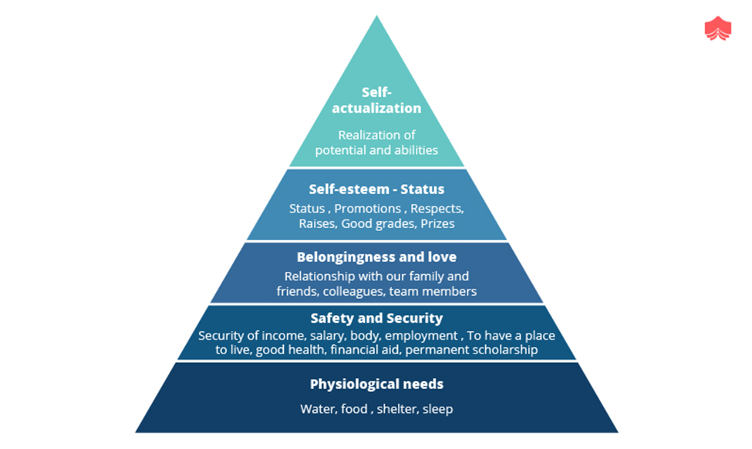
McClelland’s theory of needs
In his theory, McClelland argues that there are three basic motivational drivers which do not depend on age or one's gender. He affirms that one of these drivers in the long run dominates our behavior depending on our life experiences. McClelland categorically illustrates these three motives as follows.
- Achievement: He referred to achievement as the need and urge to accomplish a given job as a way of demonstrating one's levels of competency. He added that people with a higher need for achievement in most cases prefer tasks that require their responsibility because the results are based on their efforts and that they will always like to be acknowledged for their progress by their leaders.

- Affiliation: To demonstrate the need for social relation, McClelland defined affiliation as the need to love, the need to belong, and being accepted socially. He holds the argument that people with a higher need for affiliation are normally motivated by being loved or liked by others and for this case, they tend to participate in most social gatherings and they do not like conflicts
- Power: McClelland acknowledges that there is a dire need to have control over one's work or even the work done by others. He argued that people with a higher need for power in most cases desire situations that they can influence others and exercise power on them. Mostly their key goal is not to improve and work on their performance but they aspire to have status and authority and raise their levels of influence (Hudson, 1986).
Manifestation of the motivation theories in the Organization
For the time I was in the Mentorme organization I was able to learn a lot about that organization within a very short time. As part of service learning some of the theories that I have learned in a class all evident in the way, the organization was administered. To understand the manifestation of these theories in the organization better, I will split the theories into two parts; one part illustrates the positive side of the theories as observed in the organization while the other part reflects on the negative part.
The positive manifestation of the theories in the organization
Mentorme is an organization that prioritizes the needs of the children and the needs of the mentors who volunteer in that organization. To do this the organization ensures that everyone’s basic needs are given priority. They make sure that the workers (permanent mentors) have access to basic needs. Remember the main goal of this organization is to mentor and help the young youths to realize their real potentials and to let them know that they have got what it takes to become what each one of them desires to be in the future. Mentorme makes use of Maslow’s hierarchy of needs to arrive at their final aim of ensuring that the children have self-realization. This is a clear manifestation of the motivation theories we have learned in class and it's evident that Mentorme as an organization makes use of it.
Negative manifestation of the theories in the organization
We can all agree that there is no perfect organization. Though there were many positive things in Mentorme there were issues related to leadership that disadvantages the organization. One of these issues is poor leadership. Leadership here was in terms of the way some of the personnel’s in the top management handled volunteer mentors and the children. Some were too authoritative; something that shy’s away from anyone who might need to go there to do mentoring. Mentorship requires one to align and understand the context and the people you are dealing with and communication with these people forms the pivot for a peaceful and thriving organization. This corresponded with the McClelland theory that every individual is supposed to ensure that everyone works towards his level best to achieve the organization's goal, as well as feeling socially accepted (Al-Akeel & Jahangir, 2020). As stated some leaders are not interested in the improvement of an organization's performance but are interested in having power over others. This is exactly what was happening in Mentorme where some leaders are not sensitive to mentors' performance towards organizational goals. They ideally focus on having authority over others but forget about looking into ways that can improve mentorship to the children.
Effects of motivational theories on the organization
In psychology, cost-benefit analysis is crucial in assessing the prevailing consequences of an action. Though we have weighed and reflected on the loopholes in leadership, those are an issue that the organization can mend and it is a wakeup call for their team that does job analysis and leadership recruitment because they ought to ensure that whoever takes the leadership responsibilities is someone who creates a conducive social environment to the mentors and the children so that they can avoid chances of people refraining from volunteering as mentors as a result of poor leadership. However, the organization has also very many sensitive leaders who ensure that youths' and mentors' needs are taken care of on a timely basis which is something that has made the organization thrive amidst all existing challenges.
System theory
A brief description of system theory in social work.
In social work, system theory mainly focuses on the idea that human behavior is influenced by numerous factors that work collectively within a given system. For that matter, professionals are bound to do a critical analysis on many factors that bring forth all these changes. From that point of view, it draws an implication that social work practice is highly influenced by theory. The term theory in this context implies anything that helps us to understand human behavior. System theory for that case has predominantly been used to shape many social work practices and programs. The central idea of the system theory is helping individuals to comprehend that every person is a product of her social surroundings ("Social Work and System Theory", 1976). This way social work students get an opportunity of learning about these social system theories as well as treating and assessing them. It’s a unique field that emphasizes a person’s perspective environment and the social system theories.
The theoretical foundation of system theory
Social systems theories are a subset of the general system theory that came into existence in the early twentieth century which particularly was concerned about natural sciences and psychological sciences. The general system theory focused on the components of a system affect the whole system. Many scientists in psychology and physics started using system theories to understand what was going on around them. This initiated the need to have a stable system theory that could be used to specifically address individual and social problems. Social system theory normally contained rebuttal to the existing beliefs that most individual psychological and individual dysfunction problems mainly originate within the individual. The social system theories held the view that individuals cannot be viewed as lone islands; they must be viewed as subsets of some groups, societies, or even families (Mishne, 1982). Additionally, the system theories viewed individual problems on many levels of social ecology and these problems were shaped and influenced by many factors surrounding humans.
How system theory manifested itself in the organization.
Mentorme is an organization that seeks to help little children in the age bracket of 5-13 to have self-actualization and to shape the mind and the future of those children. This functionality in itself is a true definition of social system theory. As stated earlier the key goal of the system theory is to help individuals understand that one is a product of the system he is in. In Mentorme the youths are guided towards making the right life decision by offering them mentorship programs as well as giving them some exposure to activities that build their lives. This is a true illustration that system theory learned in school is well-practiced in mentor me. For the time I closely worked with the youths in that organization, I could tell that indeed I was touching a soul and impacting the lives of these children by bonding with them and letting them share their problems with me.
Effects of social system theory on the organization
Doing good things to others leaves you happy, resting after a busy day knowing that you have impacted someone’s life is an adorable thing. The scriptures in the book of Hebrews 27: 13:16.”And do not forget to do well and to share with others, for with such sacrifices God is pleased. Mentorme is an organization devoted to making sure that they touch the lives of the disadvantaged children in the world y igniting hope and shaping their future in the right ways. This is something that keeps the organization moving forward and motivated.
Conclusion
Servitude is a call to humanity that involves doing good things to fellow humans to impact and change their lives positively as taught in the scriptures. The service-learning I concluded was impactful and it gave me a sense of always been there for people to change and touch their lives positively. Additionally, the service-learning was a true reflection of what we have been doing in class and getting the opportunity to practice it and actualize some of the concepts in real life which to me is an adorable thing to do.

References
Al-Akeel, N., & Jahangir, S. (2020). Relationship between Employees’ Cultural Background and Work Motivation (According to McClelland’s Need Theory of Motivation). International Journal Of Psychosocial Rehabilitation, 24(Special Issue 1), 156-163. https://doi.org/10.37200/ijpr/v24sp1/pr201145
Altymurat, A. (2021). Human Behavior in Organizations Related to Abraham Maslow's Hierarchy of Needs Theory. Interdisciplinary Journal Papier Human Review, 2(1), 12-16. https://doi.org/10.47667/ijphr.v2i1.87
Hudson, L. (1986). David McClelland's Contribution to Psychology. Contemporary Psychology: A Journal Of Reviews, 31(8), 573-574. https://doi.org/10.1037/024939
Mishne, J. (1982). The Missing System in Social Work's Application of Systems Theory. Social Casework, 63(9), 547-553. https://doi.org/10.1177/104438948206300905
Social Work and System Theory. (1976). https://doi.org/10.1093/oxfordjournals.bjsw.a056695

